Ex.No: - 17

**HIGH LEVEL PROGRAMMING EXTENSIONS**

**(FUNCTIONS)**

**Program 1:**

Create a function that returns the level of a customer based on credit limit.(Use the IF statement to determine the credit limit).

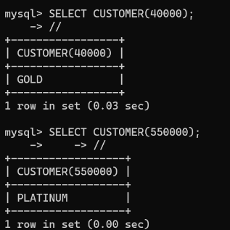

**Program 2**

Write a recursive MySQL procedure compute the factorial of a number.

